***SFCC EXERCISE SHEET***

***DAY 1***

1. Import SiteGenesis and SiteGenesis global sites into your sandbox
2. Import RefArch and RefArchGlobal sites into your sandbox

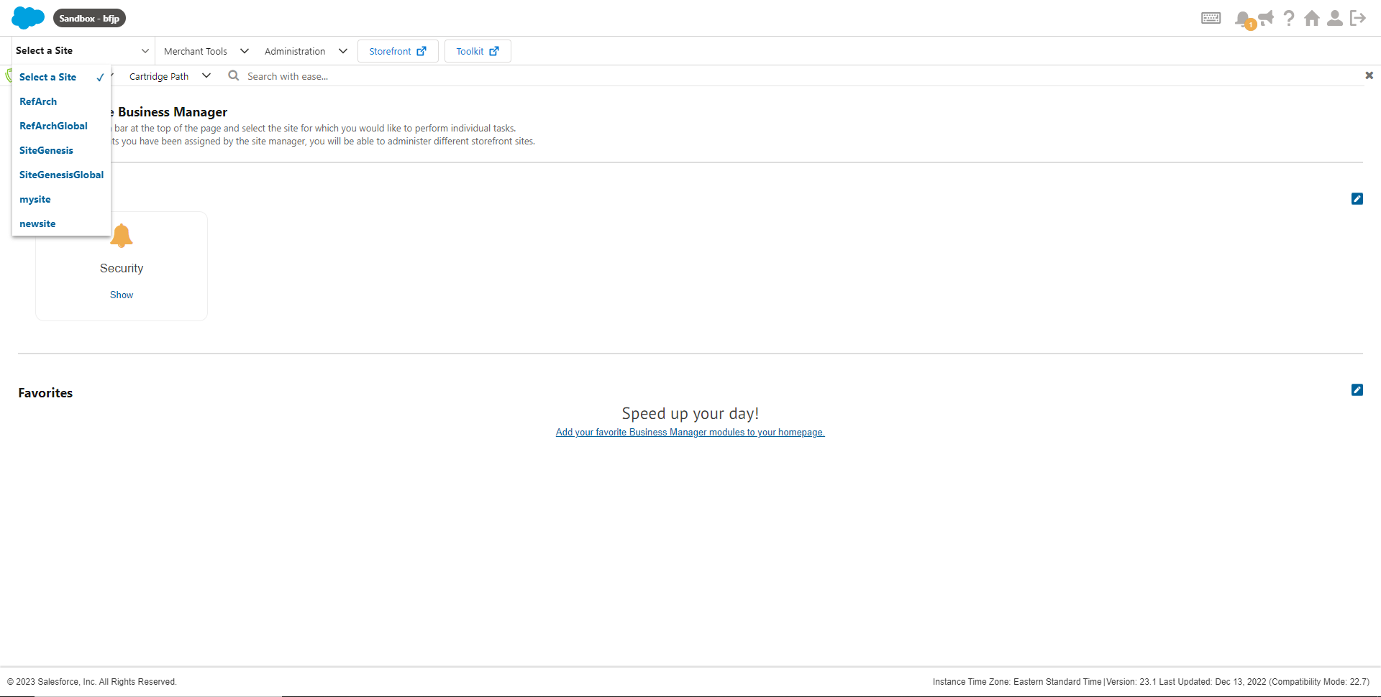

***DAY 2 AND 3***

1. Build a navigation structure (Storefront Catalog) for a new site



1. Create your own site with the id “demosite” via BM

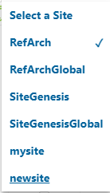

1. Assign your site to the newly created storefront catalog
2. Create a Category “Sony” and make sure all the products which have brand value as “Sony” should be assigned to this category dynamically

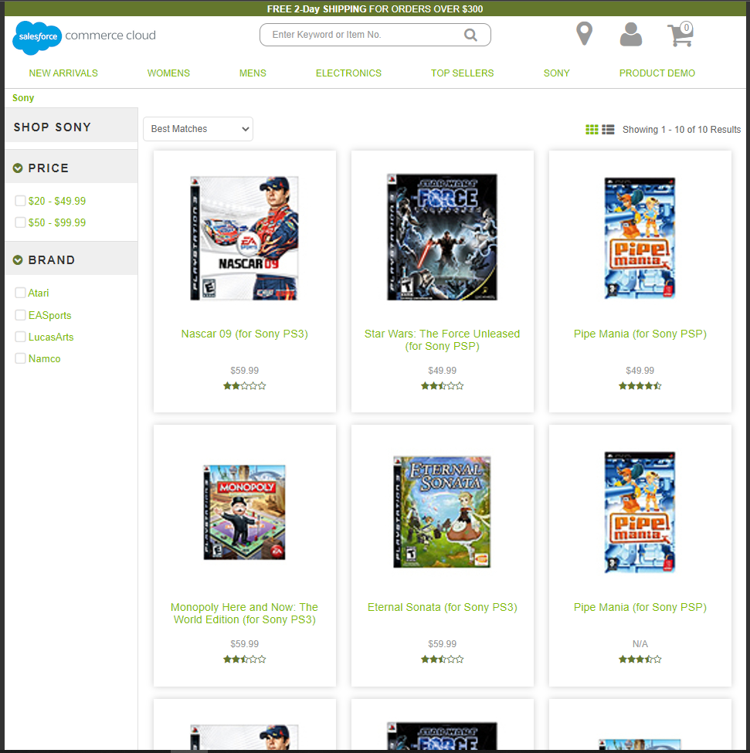

1. Make the “EARRINGS” category offline



1. 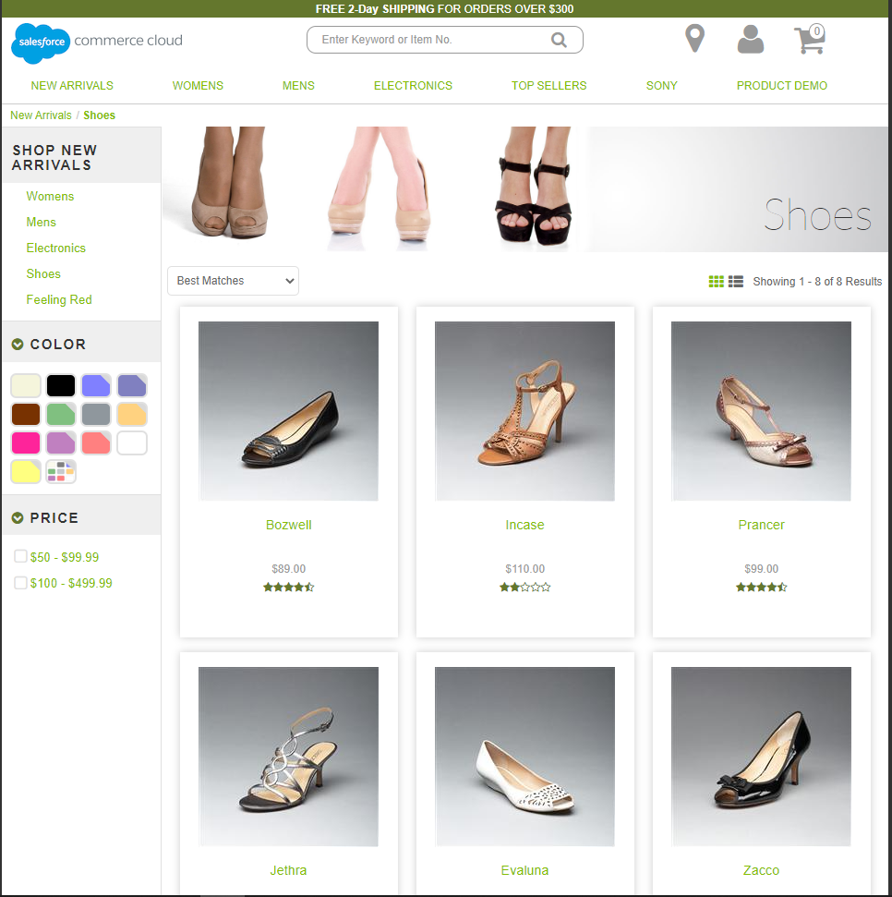Update the parent of the “Shoes” (Womens -&gt; Accessories -&gt; shoes) category to NewArrivals
2. Copy “Feeling Red” (Womens -&gt; Clothing -&gt; Feeling Red) category to New Arrivals Category

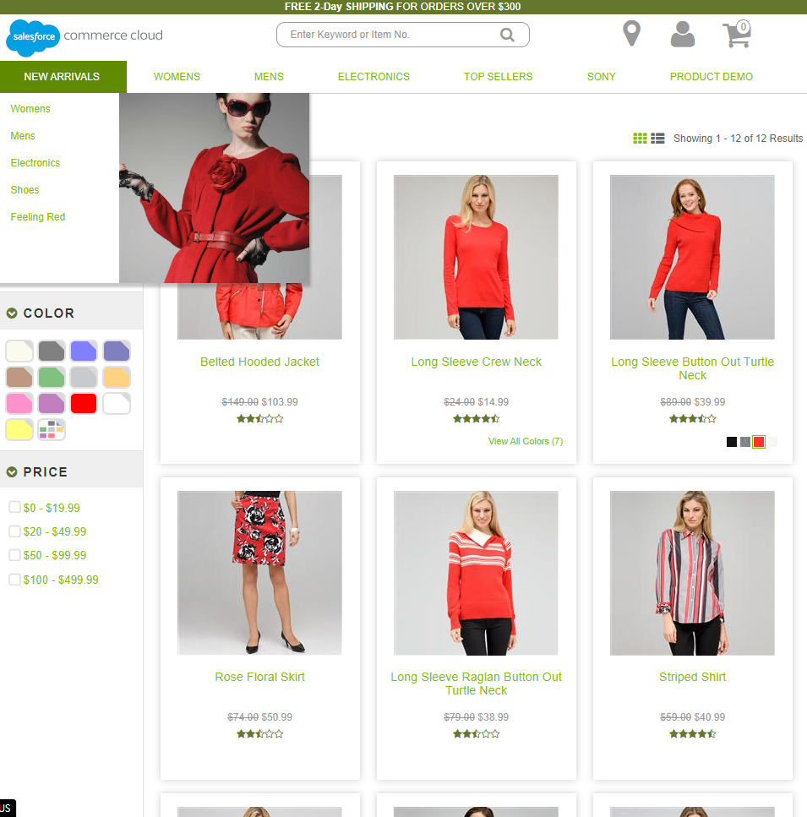

1. Create a new category “Products Demo”

* Create a Master Product and assign it to the “Products Demo” Category

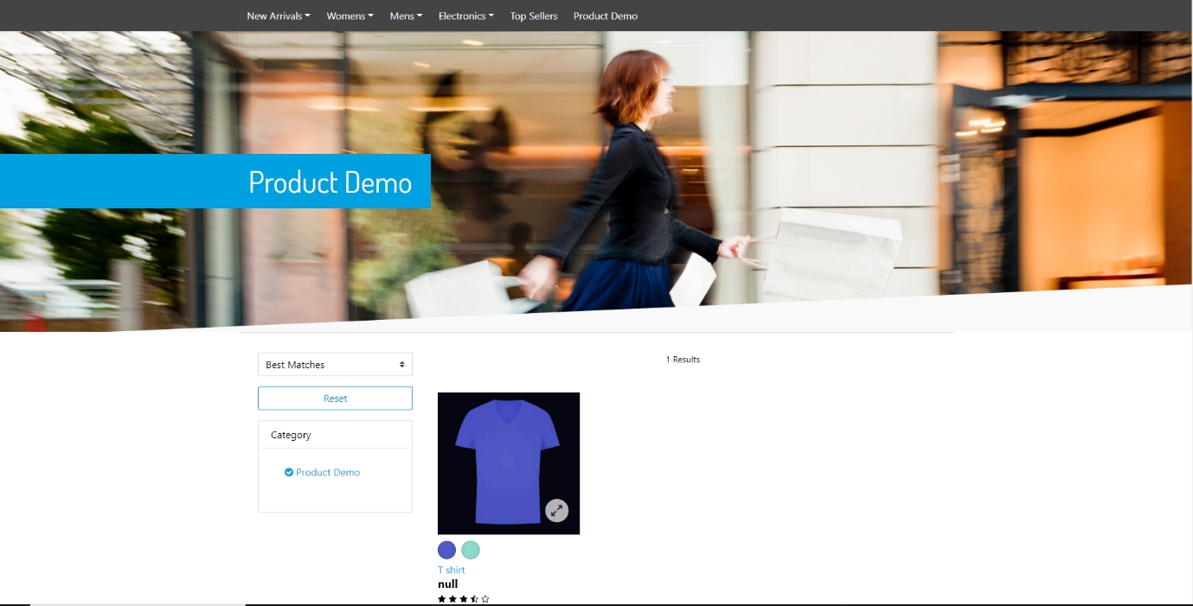

1. Use Case: Marchant wants to let customers refine products based on whether a product is trending or not

1) Create an “isTrending” custom attribute to the Product System Object Type (type “Boolean”)

2) Make the attribute available for merchandising team to view and edit

3) Define a Search Refinement based on the &quot;isTrending&quot; attribute

4) Perform the bulk edit to give the value &quot;yes&quot; for some products

5) Perform the bulk edit to give the value &quot;No&quot; for some products

6) Configure the buckets for the search refinement definition created above to make sure that “yes”, “no” values are displayed to the shoppers instead of “true”, “false”

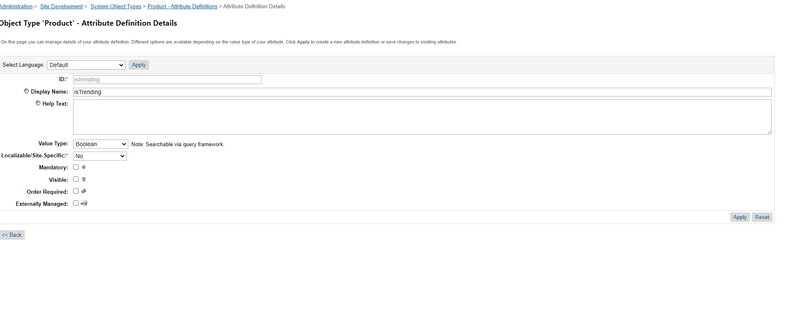

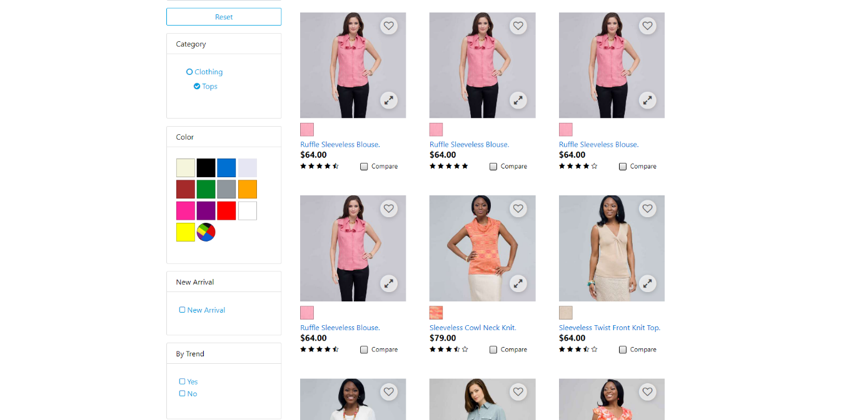

1. Adjust the Price Search Refinement Definition for the category “Womens -> Clothing -> Tops” to make sure a shopper is able to filter products in the threshold of $100 - $299.99

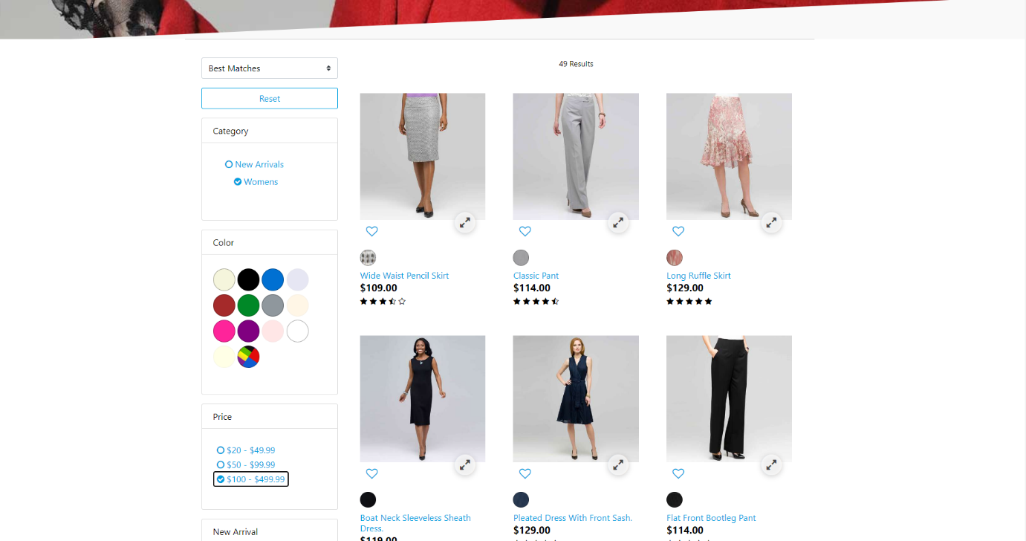

1. Explore any two existing product bundles and product sets. Create your own product set and product bundle, and assign those to the “Products Demo” Category

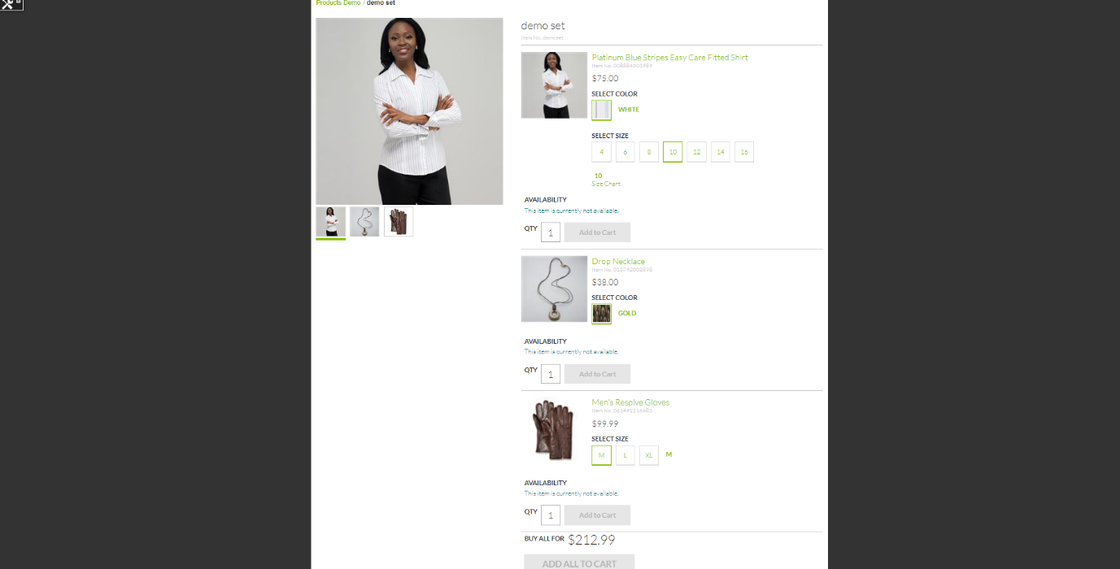

1. Create your own price book based on “usd-list-prices” and define prices for at least 5 products and assign it to your site to see the strike-out prices on the storefront



1. Make any product always available on the storefront (Inventory)



***DAY 4***

1. Make product Material(materialTest) attribute a searchable attribute
2. Bulk edit to provide value for the material attribute for some products
3. Rebuild the search index
4. Check the changes on the storefront

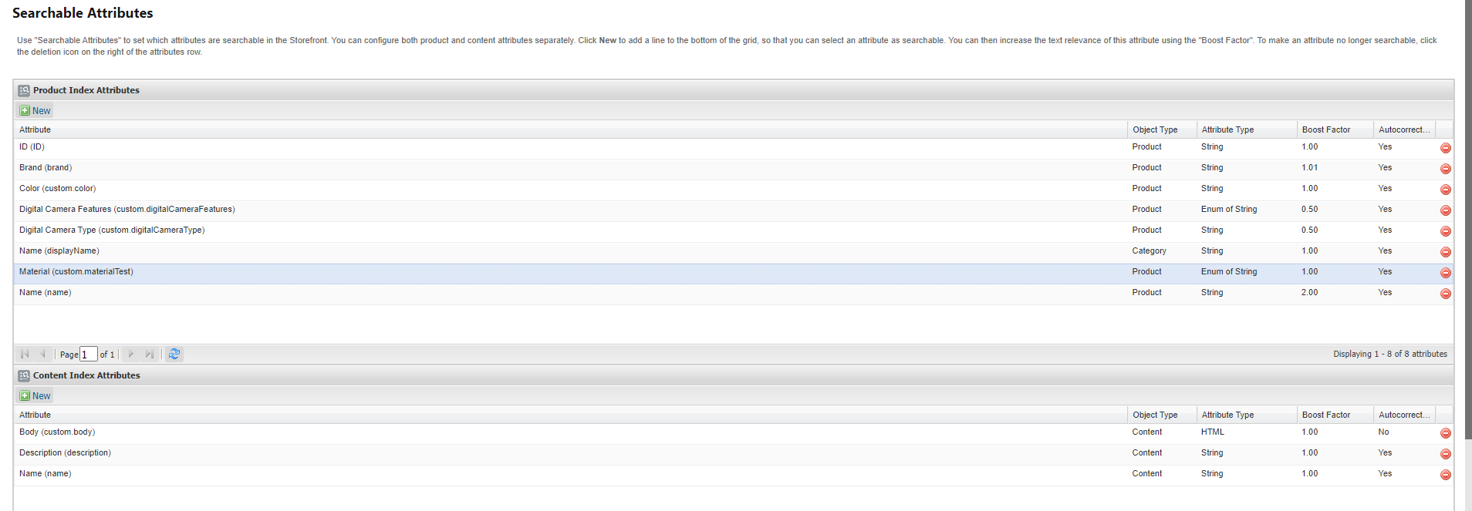

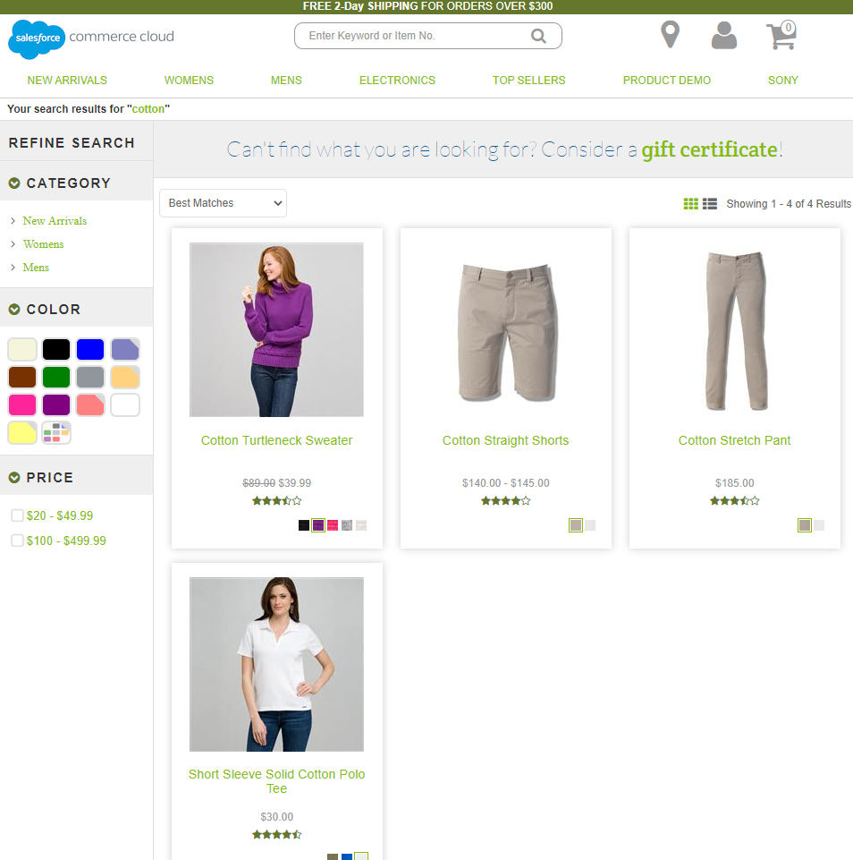

1. Override the default sorting rule for the category "shorts"

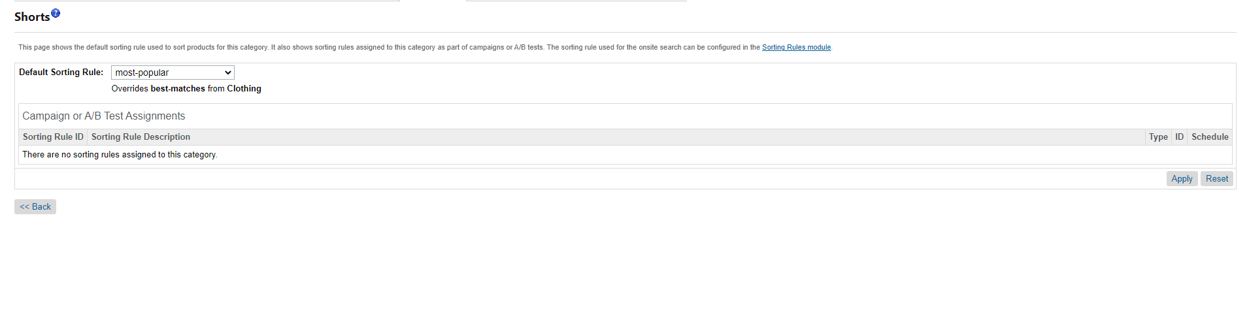

1. Override the default sorting rule for the search terms "shirts, pants, camera"

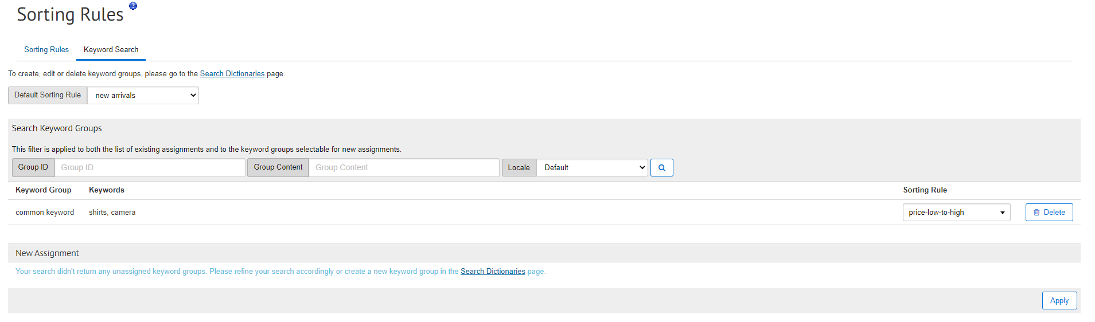

1. Create a sorting rule by using category position and text relevancy attributes

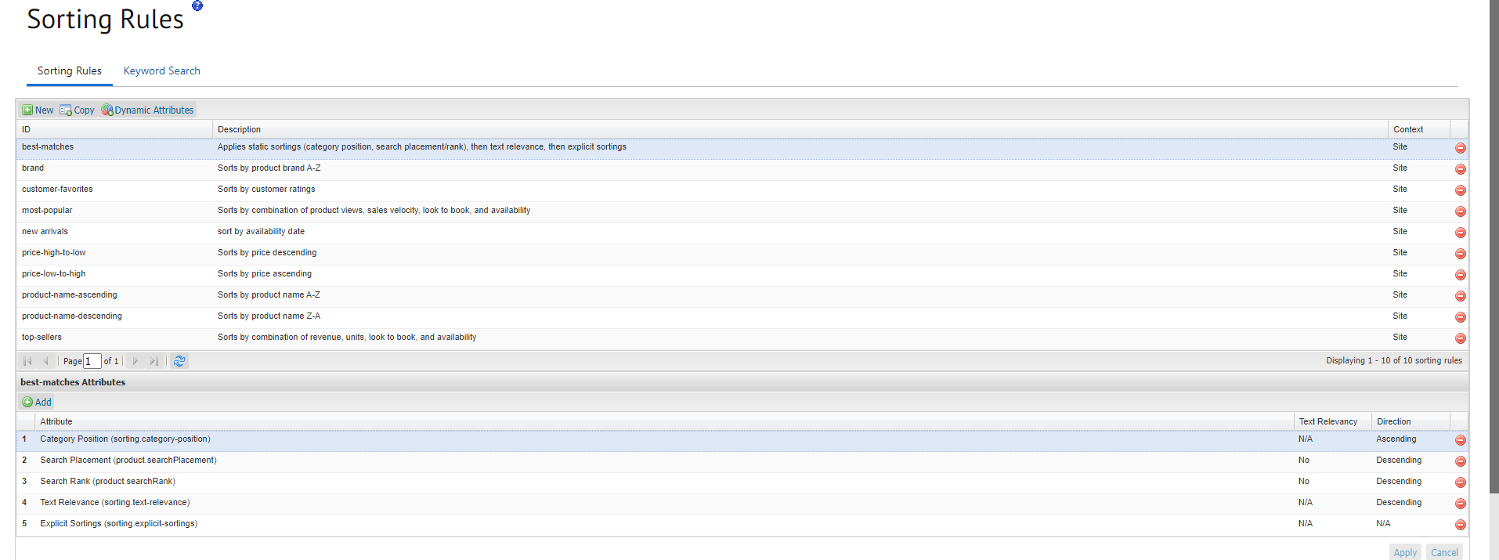

1. Create a sorting rule by using category position and text relevancy attributes

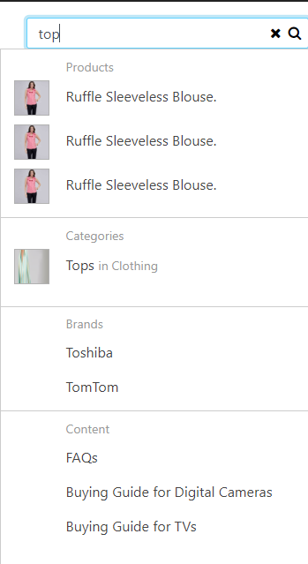

1. Block the price search refinement definition for the Electronics → Televisions category

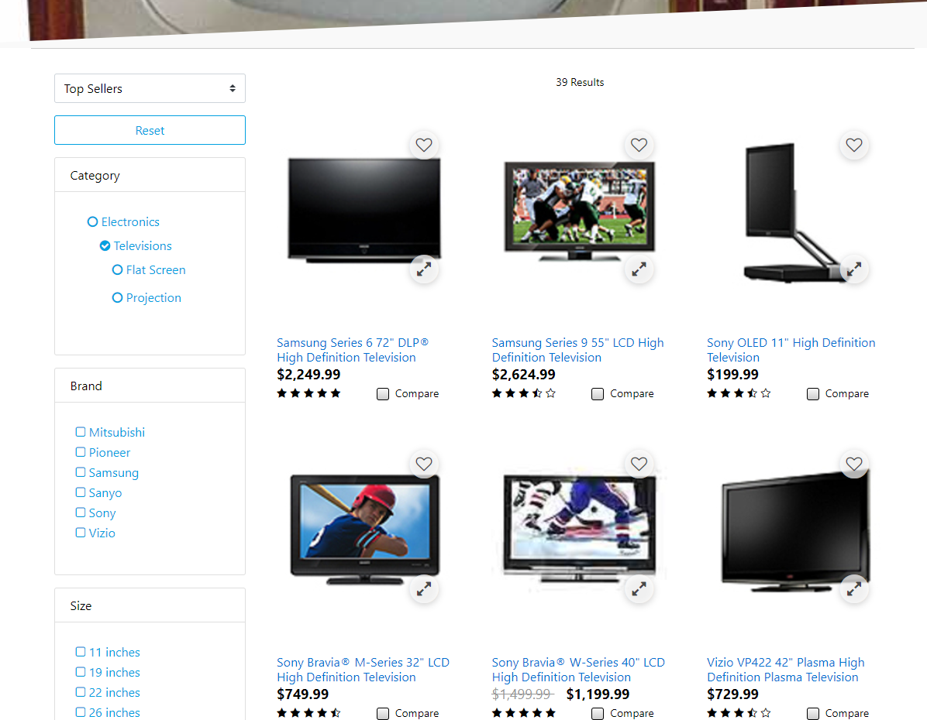

1. Configure search redirect for the “**red**” keyword to make sure it is redirecting to the “[FEELING RED](http://production-sitegenesis-dw.demandware.net/s/SiteGenesis/womens/clothing/feeling%20red/?lang=en_US)” category

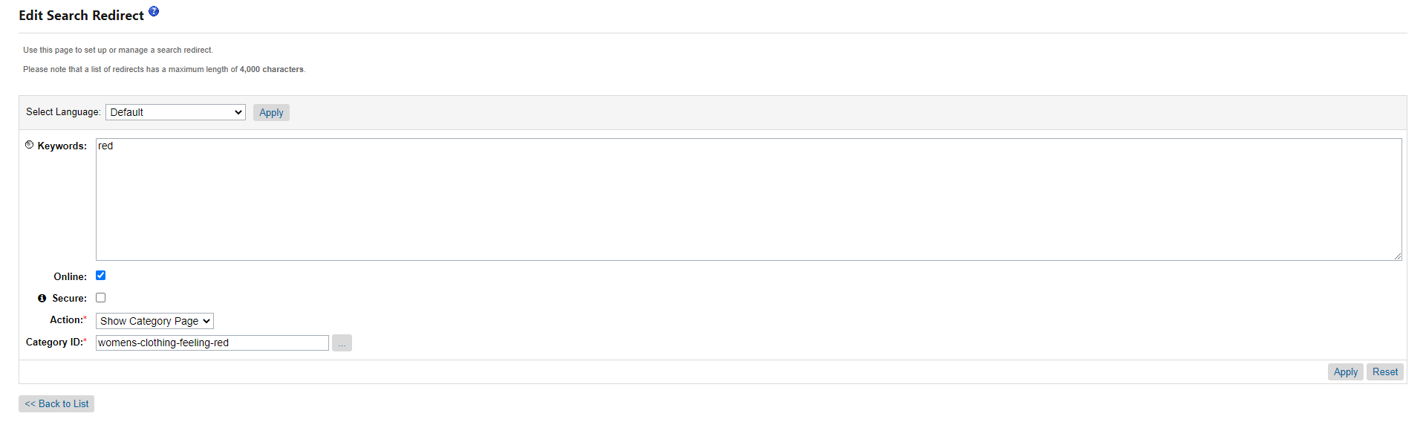

1. Configure the search settings to make sure it returns only orderable products in search results

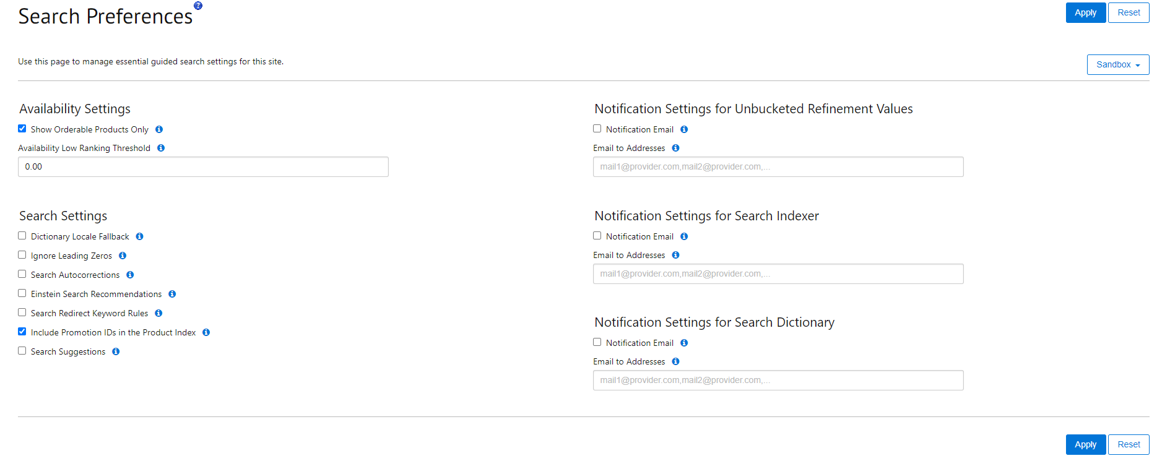

***DAY 5***

1. Create a Custom object type “NewsletterSubscription” to store the shopper info who subscribed for a brand newsletter

a. Define the following attributes in the “NewsletterSubscription” table

i. email

ii. firstName

iii. lastName

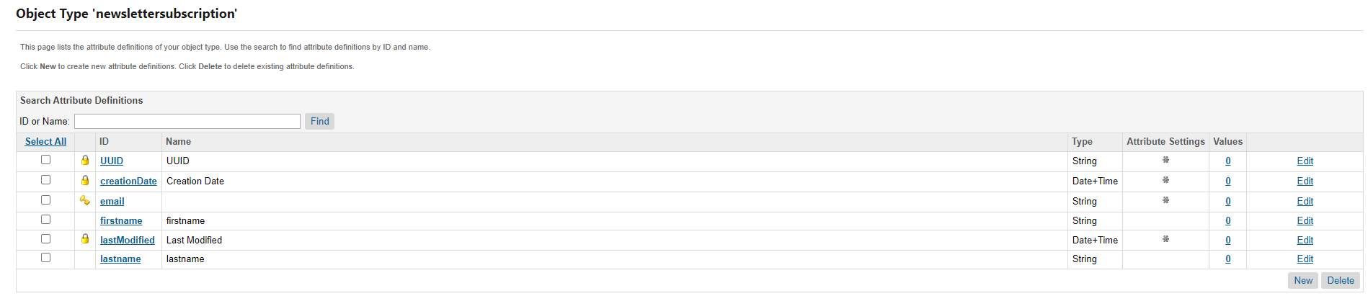

1. Create a static customer group and assign at least two customers to it

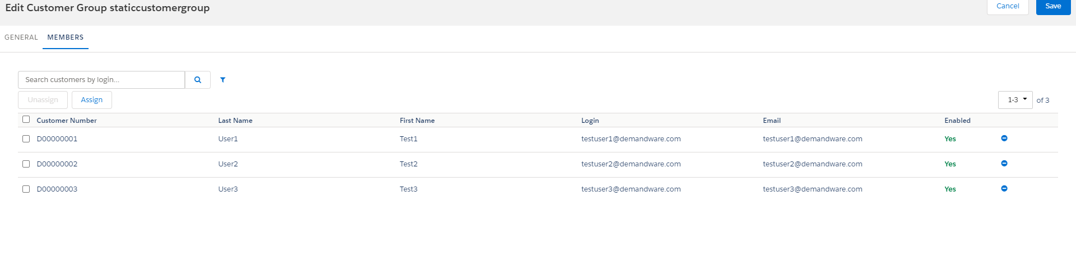

1. Create the following dynamic customer groups for your new site

a. Group 1 Rule: Customers coming from Facebook

b. Group 2 Rule: Birthday in next 30 days

c. Group 3 Rule: US Customers

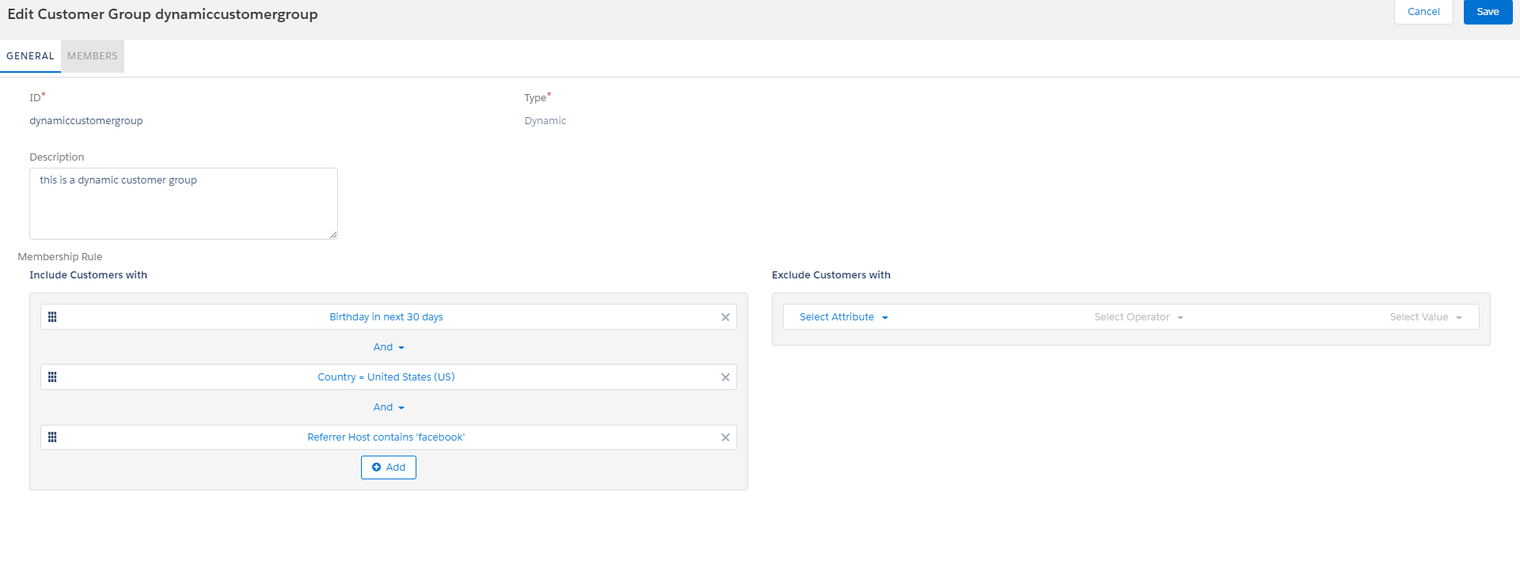

***DAY 6***

1. Create a payment method “cash on delivery” and make it available for only two countries, price range should be $500 or above and only for registered customer group

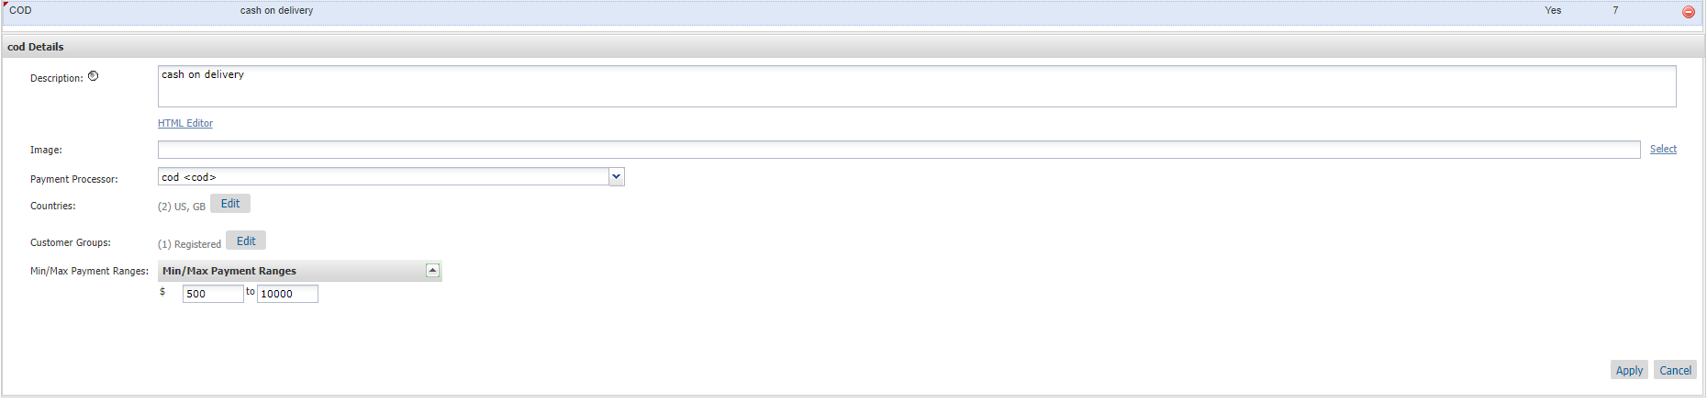

1. Create a new shipping method with currency as “USD” and make it available on the storefront only for electronics categories

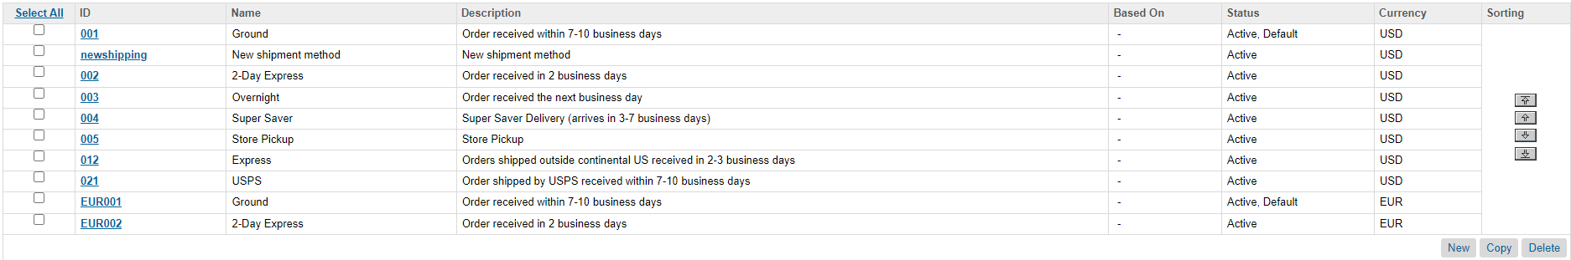

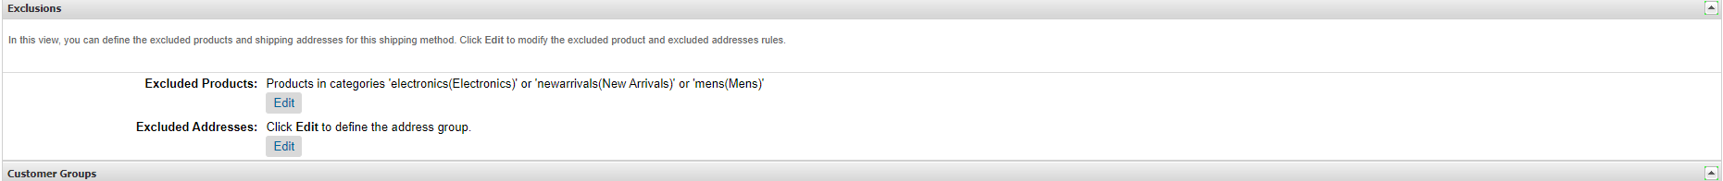

1. Define a custom tax class and configure tax rates for the US jurisdiction and this custom tax class combination

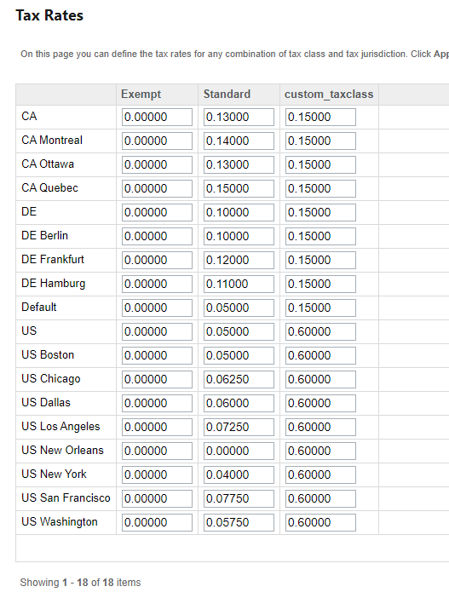

1. Use the newly created custom tax class for anyone product and check the changes on the storefront

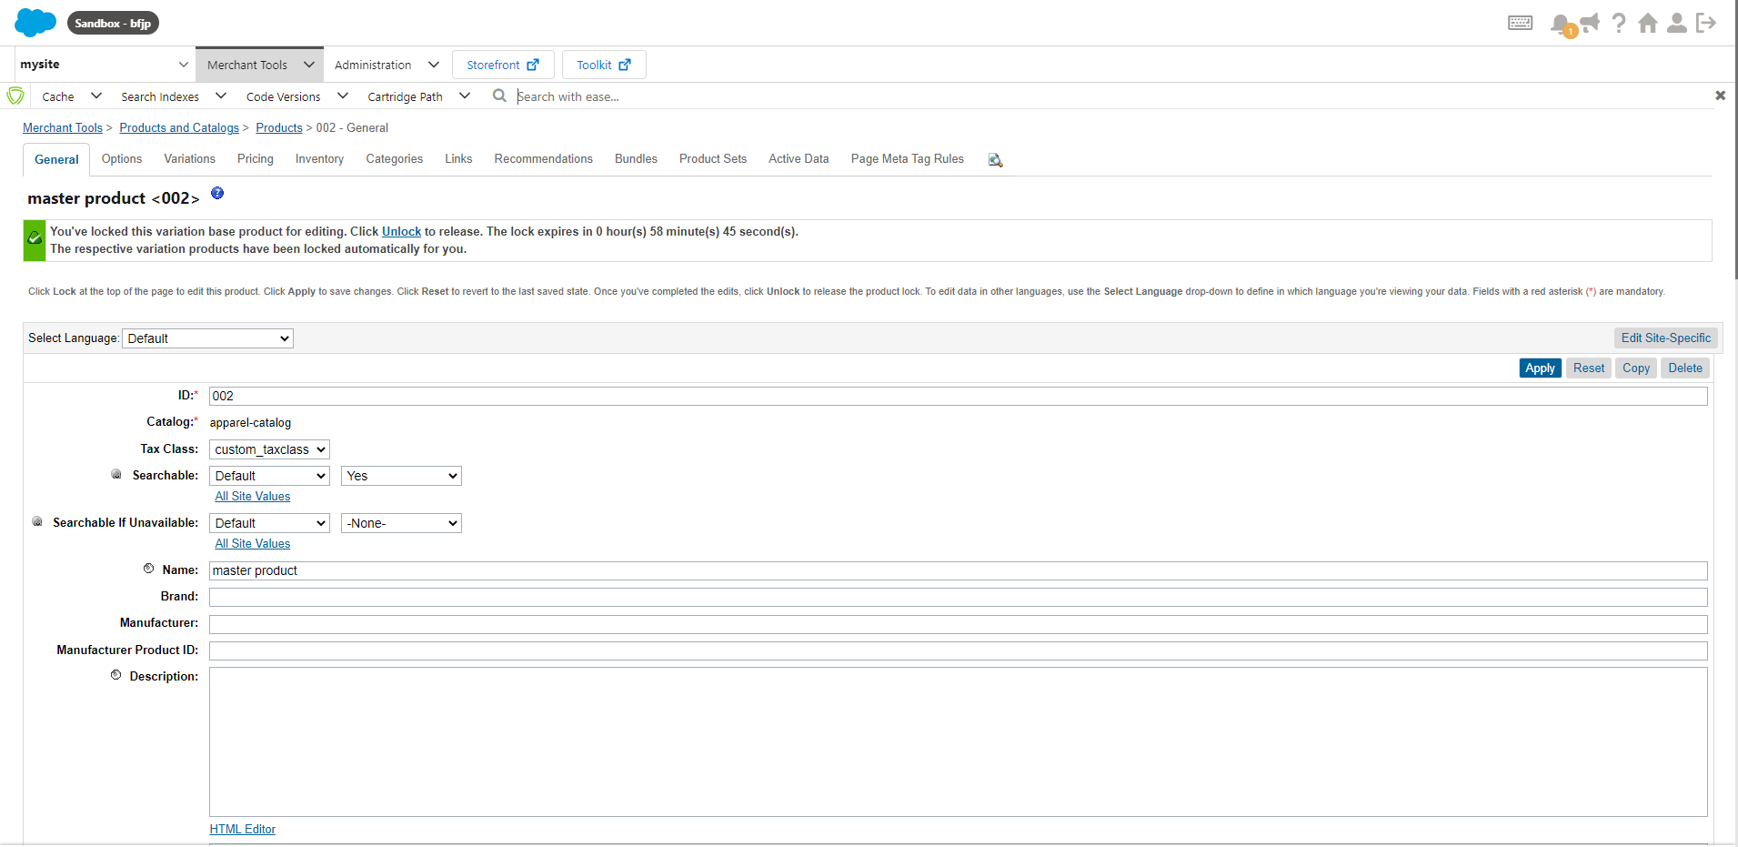

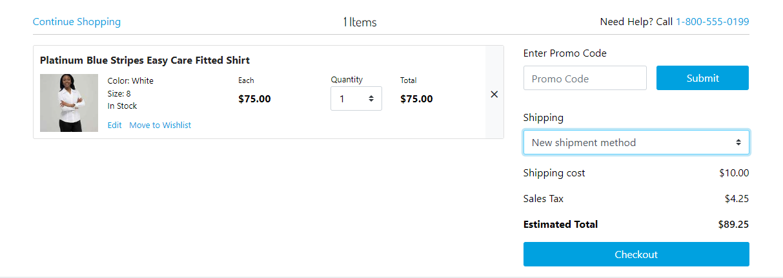

***DAY 11,12***

1. Create a new code version



1. Integrate plugin_wishlists cartridge to your site (your custom site)

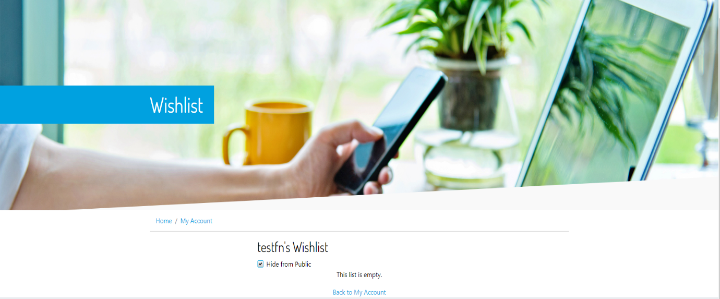

1. Create a custom cartridge “app_custom_storefront” in the “sfrademo” folder and upload it to the server

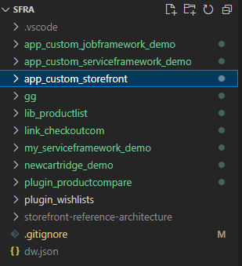

1. Create a Controller in the app_custom_storefront cartridge with a route to show a hello world message on the storefront

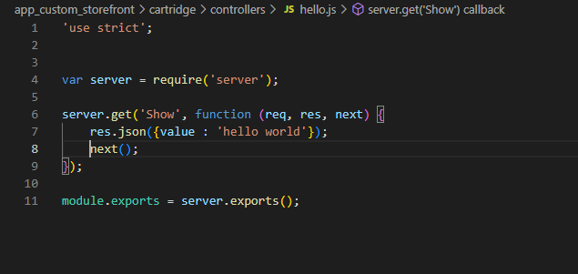

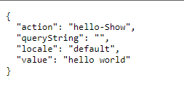

***DAY 13***

1. Create a template

Hint: Create it in the templates/default folder

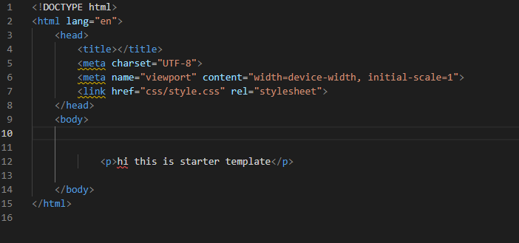

1. Create a controller and define “Start”, and “Show” routes, and make sure that the main function in both routes should render a template or JSON

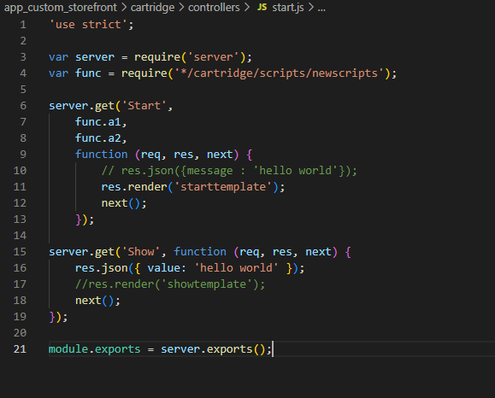

1. Create a script in your custom cartridge and define some middleware functions (ex: m1, m2, m3, m4…..)  and expose those functions to reuse

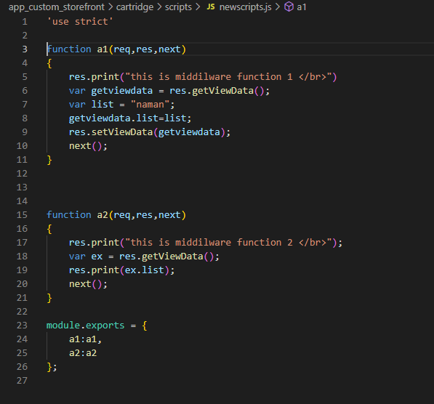

1. Require the script in your controller and add those middleware functions to your routes and check the result on the storefront



1. Set some data in your middleware functions by using res.getViewData() and res.setViewData() functions



1. Extend the “Start” route

Hint: Use the server.prepend and server.append methods

